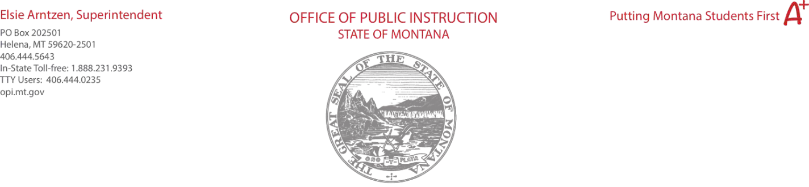

Object Codes

100 | Personal Service Salaries – Salaries
200 | Employee Benefits – Benefits
300 | Purchased Professional and Technical Services – Contracted services for administrative, professional, educational, technical, and cooperative services.
400 | Purchased Property Services – Utilities, building usage charges, repairs and maintenance services, rent, minor construction.
500 | Other Purchased Services – Student travel, employee travel, professional development, registrations, communications, printing.
600 | Supplies – Instructional supplies and materials, textbooks, library materials software, minor equipment

Purpose Categories
10 Instruction - Activities dealing directly with the interaction between teachers and students.

- Support Services –
  - Instructional Staff – Activities associated with assisting the instructional staff with the content and process of providing learning experiences for students (i.e., improvement of instruction services, designing curriculum).

  - Students – Activities designed to assess and improve the well-being of students and to supplement the teaching process. Non-instructional paraprofessionals should be recorded here.

- Parental/Family Involvement – Activities provided by and for parent/guardians to learn about the intellectual and developmental needs of their children and to participate constructively in their children's education.

- Professional Development – Activities associated with high-quality professional development and training of school system personnel including in-service training and workshops.

- Administration – Includes support services for general administration, school administrators (i.e., federal program staff at the district office, district facilitators), and businessoffice.

27 Pupil Transportation – Activities concerned with the conveyance of students to and from school, as provided by state and federal law. Includes trips between home and school.

33 School and Community Support – Activities concerned with providing community services to students, staff, or other community participants. Activities performed by students that address a given community need and provide for structured opportunities linking tasks to the acquisition of values, skills, or knowledge by participating youths.

40 Facilities – Activities concerned with the acquisition of land and buildings; remodeling and maintenance of buildings; construction of buildings and additions to buildings.

(return to top)

Use of Funds

Technology - Educational technology (hardware, software, and connectivity) for use by teachers and administrators.

Dedicated Learning Devices for Students – Educational technology (hardware, software, and connectivity) for use by students. Which may include assistive technology or adaptive equipment.

Home Internet for Students – Providing home access to the internet for any student. Supplemental Learning – Providing summer learning and supplemental afterschool programs.
Address Learning Loss – Providing learning activities that directly address the general loss of knowledge and skills or to reversals in academic progress.

Supplemental Services – Activities focused specifically on addressing the unique needs of low- income children or students, children with disabilities, English learners, racial and ethnic minorities, students experiencing homelessness, and foster care youth

Minimize Spread of Infection – Sanitization and minimizing the spread of infectious diseases, including cleaning supplies and staff training to address sanitization and minimizing the spread of infectious diseases.

Mental Health – Mental Health services and supports.

